Understanding the Report Summary
The report summary provides a snapshot of the body’s overall wellness. You can click on a square to get more information about what each measurement is and what it says about your health.

Based on heart rate, heart rate variability, breathing rate, skin age, and mental stress index measurements, we’re then able to see which body biomarkers are in range, and which ones are out of range. The biomarkers that are scanned include body systems, such as the Immune System, lifestyle areas, such as Hydration, and Emotions.

When a biomarker shows up as out of range, we know that it’s something for which the body may need some support to bring back into range, or back into energetic balance.

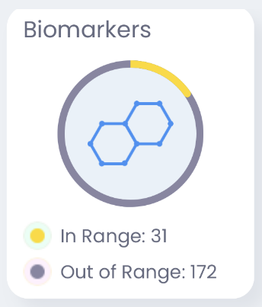

This circle shows us how many biomarkers were in range overall, and how many are out of range in total as well.

Navigating the Systems Report
The Systems Report provides further detail about each biomarker that was scanned, allowing you to dig deeper and find out which areas may require additional support.

To view this report, select Systems at the bottom of the screen.



Now you can see the responses for each category that was scanned. Select any category (not the checkbox) to view top products and biomarker responses for that category.

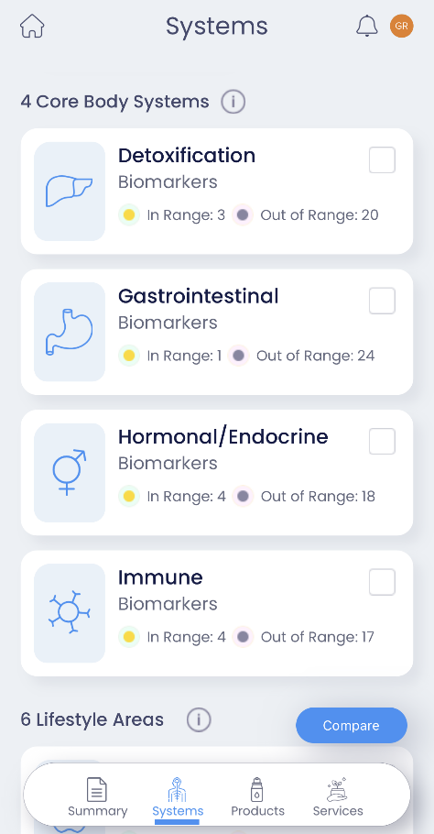

At the top, you’ll see the total in-range versus out-of-range biomarkers, then toward the bottom of the screen are the responses for each of the specific biomarkers in that category.

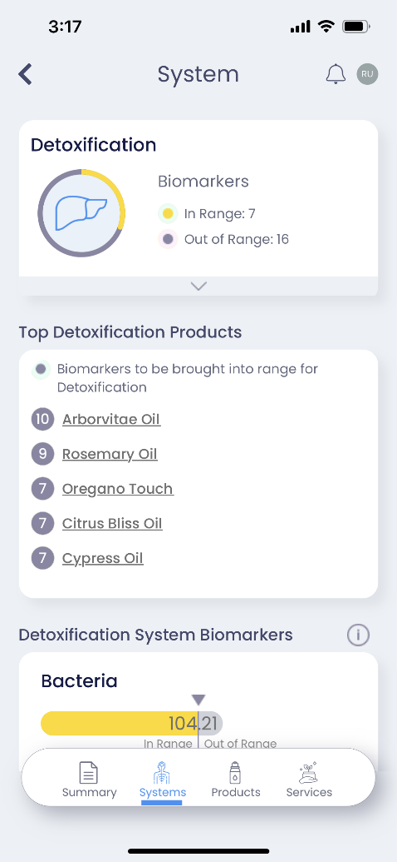
This vertical bar is the body’s baseline range. Anything that has grey extending past this bar is out of range. The bigger the number, the more out of range the biomarker is. So, you’ll want to pay particular attention to those items and consider how the out-of-range biomarkers impact each other, as well as the system.

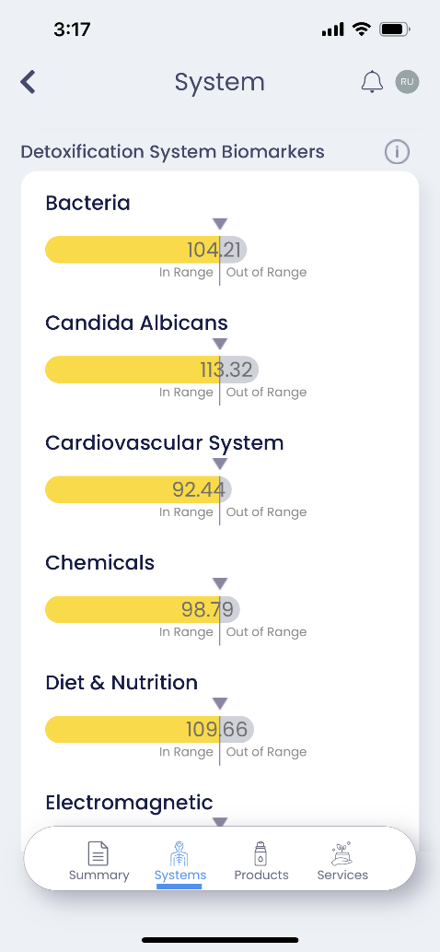

Back at the top, we also have the specific products that will bring the out-of-range biomarkers back into range. The number to the left is how many biomarkers the product will bring into range for that specific system.

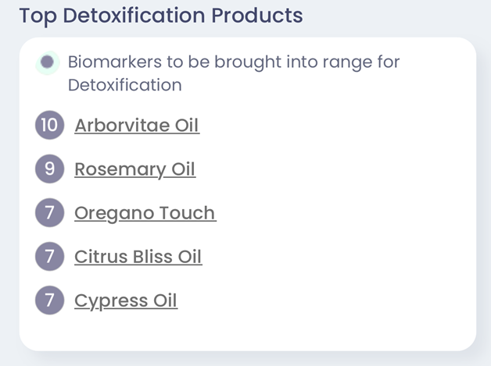

Going back to the main report screen, you’ll typically want to find the top 1 or 2 systems in each category group (Systems & Lifestyle Areas/Emotions) that have the most out-of-range items and select the checkboxes next to those, as they are the most significant.

Once you’ve checked all the systems you want to compare, select the Compare button. This aggregates the selected categories together and shows the top products across all categories you’ve selected. This is a great way to see which products best support those key categories.

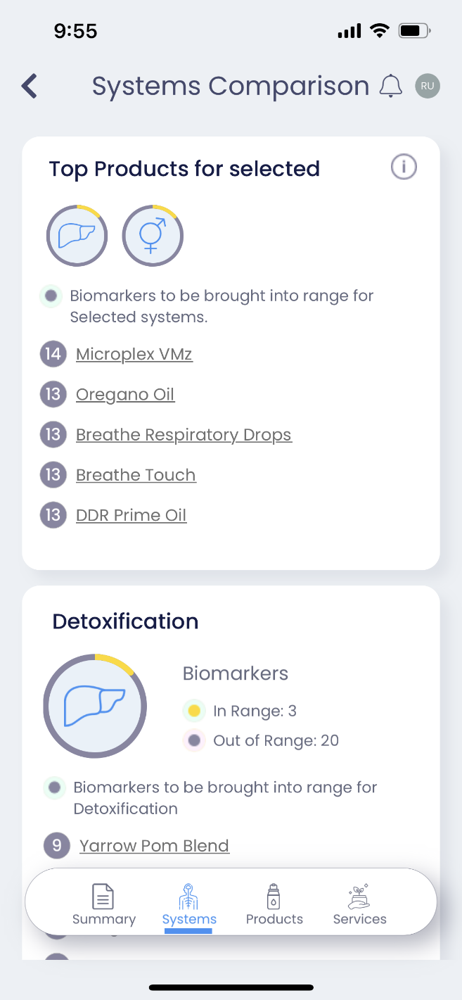
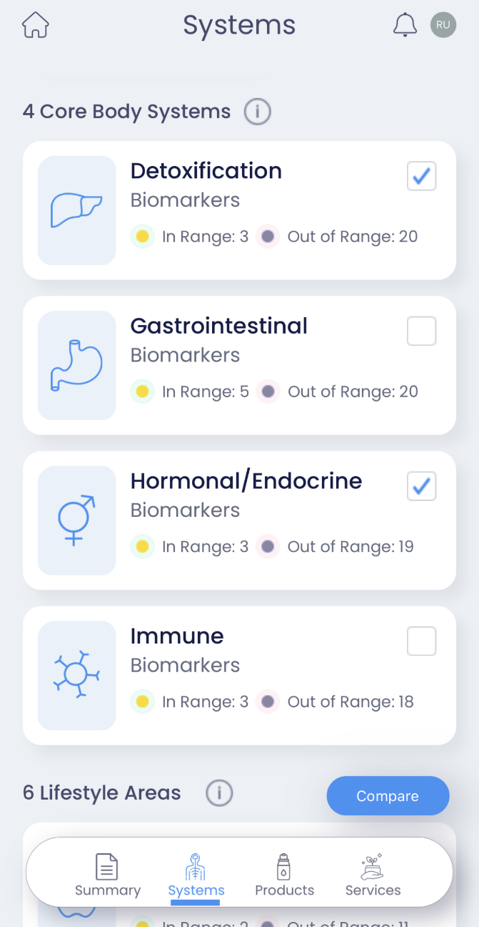

The responses for each compared category will be shown below the top products. Chances are that you’ll see your top overall products in several of these other categories, as well.

From this Systems Comparison screen, you can take note of any products you would like to add.

Selecting Products
Along with scanning key body and lifestyle biomarkers, ZYTO Link also scans the body’s preference for oils and supplements from your product line. Once we know which biomarkers are out of range, these products are then scanned to see how many biomarkers they bring back into range. We can see these results in the Products section of the report.
To access this report after running a scan, select Products at the bottom of the screen.

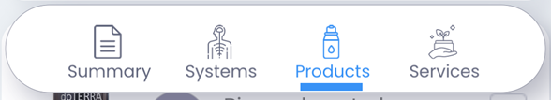

Below the Biomarkers from all Systems section, you’ll see the top products and how many biomarkers each one brings into range. Generally, you’ll want to select the products that bring the most biomarkers into range until you get them all, or the large majority of them, in range.
With selecting products, the goal is to get the best bang for your buck. So, if you can get all the out-of-range biomarkers back in range with 2 or 3 products instead of 4 or 5, for example, that’s going to be better.
Generally, you’ll want to select from the top down until everything or nearly everything is brought into range.
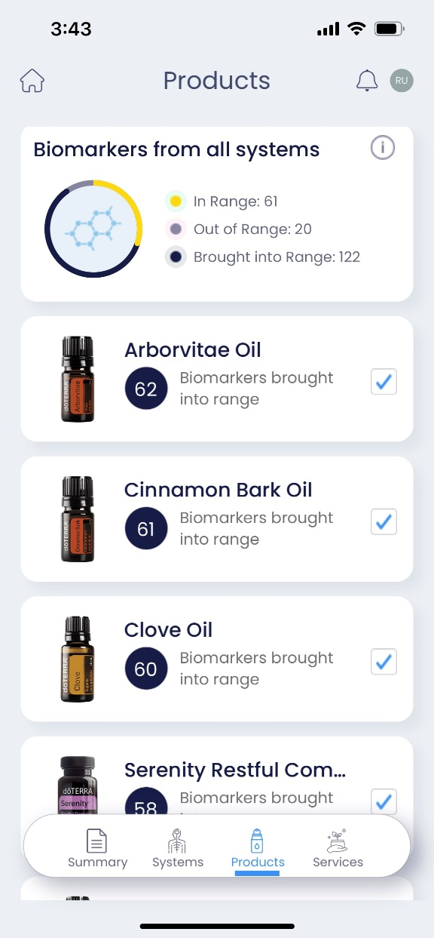
You can also select a product (not the checkbox) to get more details about it. This additional detail includes dosage, related systems, indications, and all the biomarkers that product brings into range.
For any of the sections in the product detail page, you can simply select an item to see a brief description, and then you can select Learn more to learn even more about it. And once you’re done, just select the back button to go back to the main Products screen.
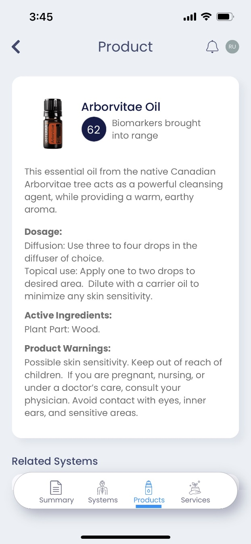
To find products that benefit multiple systems, start by adding those top one or two products that showed up across multiple systems. After that, you can add additional products to bring more biomarkers back into range.
One additional thing to note is that the products you would like to add from the Systems report may not be in this Products report, as this only shows the top 5 products overall. So, in addition to what you select here, there may be another one or two from that Systems report that you can add to these.
As you select the checkbox next to each product, it will increase the “Brought into Range” number and decrease the “Out of Range” number. So again, you’ll want to get this number as small as possible, ideally zero, with as few products as possible.

Considering Services for Additional Support
Wellness services in the Link app include those that require a visit to a practitioner, as well as general services that can be done on your own, such as exercise. The body’s top 5 service responses are shown in the Services Report.
To access this report, select Services at the bottom of the screen.

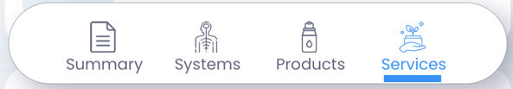

Unlike Products, Services can’t be selected and added to your “Biomarkers brought into Range” count. Instead, the number just gives you an idea of the impact it will have on the body energetically.

To see more details about a service, select it and you’ll see a brief description of the service. You can
select Learn More if you want some additional details about the service. And then once you’re done, you can just select the back button to go back to the Service Detail screen.

Another nice feature here is that you can see the specific biomarkers that the service will bring into range. And you can select any of these for more details about that biomarker as well.

Back on the main Services screen, let’s talk about recommending services.

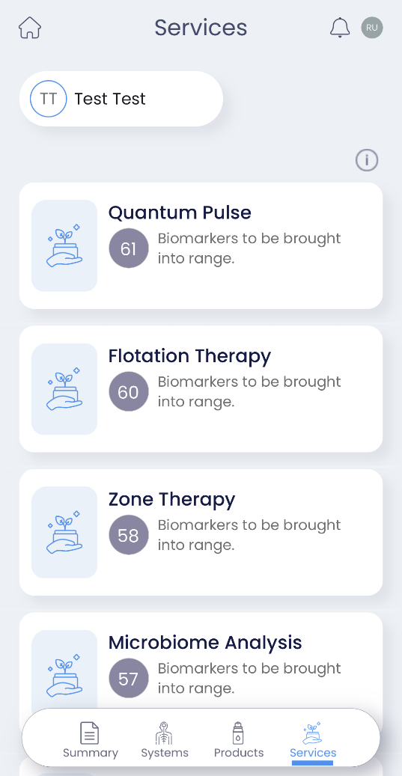

Generally, you would recommend a service in addition to the products that brought the biomarkers into range. However, if you see that a particular service addresses many of the same biomarkers as a product you previously selected, you may want to replace the product recommendation with that service. It’s really up to you and what you think would benefit your client the most based on the data.

